V.V.Sangha’s
Smt. A.S.M. College for Women, Ballari.
Teaching Faculties of M.Com. Department for the A.Y. 2020-21
Sl. No. | Name of the Faculty | Designation | Specialisation | Photo | Contact
1 | Dr. Gavisiddappa Gadag  M.Com., Ph.D. | Coordinator | Accounting and Finance | 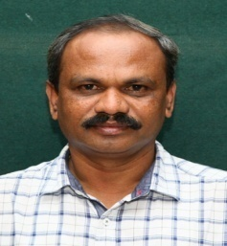 | gavi8865@gmail.com  +91-9448435474
2 | Dr. Mallareddy T  M.Com., Ph.D. | Lecturer | Accounting and Finance | 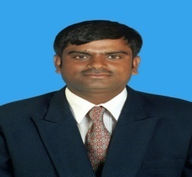 | tmallareddy3@gmail.com  +91-9844862463
3 | Ms. Gayatri M P  M.B.A., M.Com., UGC-NET, KSET, (Ph.D.) | Lecturer | HR, Marketing and Finance |  | mp.gayatri@gmail.com  +91-8123387123
4 | Ms. Divya Budur  M.Com., | Lecturer | Finance | 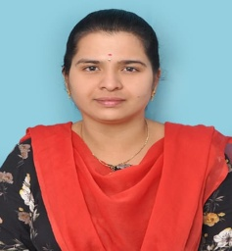 | divyabudur22@gmail.com  +91-7975957882
5 | Mrs. Rini Gattina  M.Com., LL.M., | Lecturer | Business and Companies Laws | 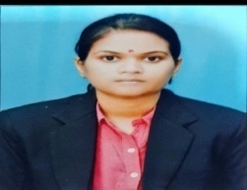 | aarnasiddharth@gmail.com  +91-9620876007
6 | Mr. Khaja Mohinuddeen J  M.Com., UGC-NET, KSET, APSET, (Ph.D.) | Lecturer | Accounting, Taxation and Finance | 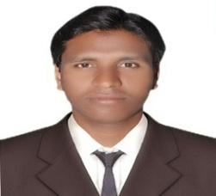 | profkhaja@gmail.com  +91-9449717652
7 | Ms. Ashwini J  M.Com., KSET | Lecturer | Accounting and Taxation | 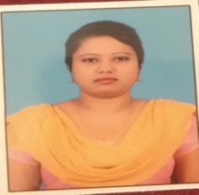 | krishnaashwini123@gmail.com  +91-7090433510
8 | Mrs. Poornima Hulipalled  M.C.A., | Lecturer | E-Commerce | 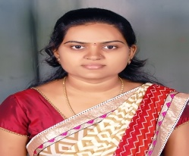 | poornima.algur@gmail.com  +91-8904569073

