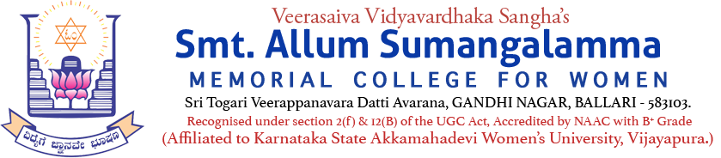
Internal Quality Assurance Cell (IQAC)
Zoology Department
Programme: BSc Departments: CBZ
Name of the Programme | KMF Study Visit, July – 2026
Category | Experiential Learning activity
Venue, Date & Time | KMF, 30.07.2026, 10.00AM TO 05.00PM (One Day Visit)
Target Audience &  Participation of Students and Staff | UG B.Sc. CBZ Students  (Attendance Sheet Copy Enclosed)
Brief Report on activity | The Department of Zoology has organized a one-day visit for BSc-III semester CBZ students to KMF-Ballari on 30.07.2026. The purpose of the visit was to make students understand milk collection, storage, processing, transportation & marketing, and its byproducts along with job opportunities in dairy. Dr. Syeda Kahkashan Tanveer, HoD Zoology & IQAC Coordinator; Ms. K. Rakshitha & Ms. Divyashree, teaching staff members of the Zoology Department, along with Mrs. Mamata, non-teaching staff of the department. We are highly thankful to Chairperson Smt. KATHYAYANI M. MARIDEVAIAH & College Principal Dr. DUPAM SATEESH for permitting us to undertake such a study visit for the students. Around 47 students from the BSc-3rd semester participated. The Department is highly thankful to the general manager of the ice cream plant, Ballari, along with the technical staff, for their cooperation in the successful visit and for providing ice cream to the students. Special thanks to Ms. Saroja Madam (an alumnus of the college) for briefing us about dairy & providing flavored milk to all.
Geo Tagged Photos Social Media Web link | https://www.facebook.com/share/p/1WGVDmmnZk/
HEI Web link of the Event | Zoology Department Experiential Learning activity - KMF study visit held on 30.07.2026
