B.Sc.-V Semester-Study Material:
NON-CONVENTIONAL & RENEWABLE ENERGY SOURCES
Since energy is an important input in all sectors of any countries economy, the standard of living is directly related to per capita energy consumption. The present crisis is due to
- Rapidly increasing population
- Continuous usage of NON RENEWABLE energy sources.
- More demand, less production
- Wastage
- High standard of living
If the present trend continues the fear is that the fossil fuels and nuclear energy will get exhausted in the coming days. So the task is to address the problem of energy crisis and manage a transition from dependence on conventional sources to NON-CONVENTIONAL and RENEWABLE SOURCES.
To meet the future energy demands and to give quality, pollution free supply of energy to the growing and environment conscious population , world attention is drawn towards natural, clean, green and sustainable NON-CONVENTIONAL and RENEWABLE ENERGY SOURCES.
In reality NON-CONVENTIONAL and RENEWABLE ENERGY is the energy from a source that is replaced rapidly by natural process and is not subject to depletion in a HUMAN TIME SCALE.
There have been many attempts to find a suitable term to describe the whole range of technologies designed to tap earth’s natural energy flow like ‘alternate’ ,’natural’,’ new’… However the term RENEWABLE has gained the most wide spread acceptance.
Coming to the energy scenario in India, our country ranks sixth in the world in total energy consumption that is 34% of global consumption.70% of its needs are met through imports mainly in the form of crude oil and natural gas. Since independence more than 500,000 villages have been electrified, still 80,000 villages are yet to be electrified. So, the Indian power sector is undergoing a rapid growth phase with a vision to provide reliable, affordable and quality power for all. Hence the MINISTRY OF POWER has drafted NEW and RENEWABLE energy policy statement issuing guidelines to develop new and renewable energy technologies as per international standards.
India has the world’s largest programme for renewable energy. Government has created the department of NON-CONVENTIONAL ENERGY SOURCES in 1982. In 1992 a fully fledged ministry of NON-CONVENTIONAL ENERGY sources was established under the overall charge of the Prime Minister.
The NON-CONVENTIONAL ENERGY SOURCES are Solar, Wind, Biomass, Geothermal , Energy from Oceans, Chemical Energy Sources, MHD (Magneto Hydro Dynamics) Thermo Nuclear Fusion, Thermo-Electric and Thermionic Converts, of which the NON-CONVENTIONAL AND RENEWABLE ENERGY SOURSES are Solar, Wind, Ocean, Biomass, and Geothermal Energy. These energies are clean, eco-friendly and inexhaustible.
India is blessed with an abundance of sunlight, water and Bio-mass of which solar energy can emerge as a major and ideal power source in remote and isolated areas which are not served by conventional electricity. The most significant applications are Solar Cookers, Solar water heaters, Solar Water pumping, Solar Street lighting, Solar drying and solar refrigeration.

Wind energy is another important aspect of NON-CONVENTIONAL AND RENEWABLE ENERGY SOURSES. The energy available in the winds over the earth’s surface is of the same order of magnitude as the present consumption on the earth.

India now ranks as a “WIND SUPER POWER” with this effect the Government of India is encouraging the public to take up the projects of installing “Wind Farms” by giving periodical tax holidays.

Currently “SUZLON” an Indian company is a market leader in wind power in Asia and 3rd largest manufacturer in wind power turbines in the world. In Karnataka we can locate these “wind farms” in the districts of Gadag and Chitradurga.

Wind mills have been used for several centuries in Netherland, Denmark and Norway, where high velocity wind is available in abundant quantity. Wind mills have been used for grinding grains and pumping water, dozens of centuries ago. Interest in large scale power generation has developed over the past few decades.

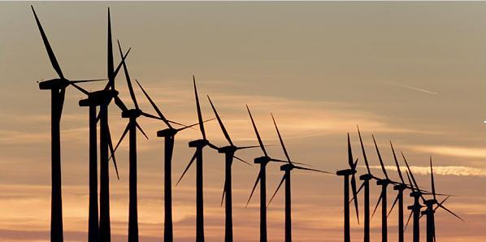

Another feature of NON-CONVENTIONAL and RENEWABLE ENERGY SOURCE is BIOMASS which is an organic matter produced by plants both terrestrial and aquatic. Biomass falls in three categories
- In traditional form it is solid mass i.e., Agriculture Residue.
- In non-traditional form it is converted to liquid fuels like Ethanol and Methanol.
- Fermented Biomass is called Biogas.

India is predominantly an agricultural economy with an estimated production of 350 million tonnes of agricultural waste every year, from which it is capable of producing 17,000 MW of power resulting in saving of about Rs.20,000 Crores every year.
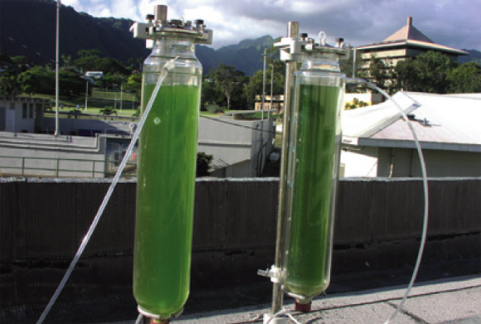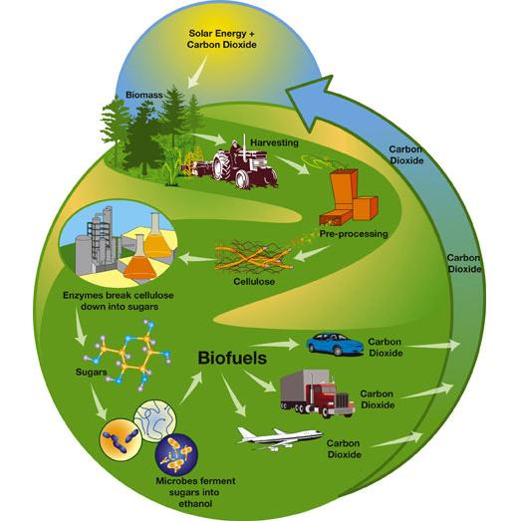

Another component of NON-CONVENTIONAL AND RENEWABLE ENERGY IS “GEO-THERMAL ENERGY” it is the energy present as heat in the earth’s crust. It is potentially useful and almost inexhaustible source of energy.
In India Geo-Thermal wells are found in Himalayan provinces of Haryana and Himachal Pradesh, Barren Islands of Andaman and Nicobar, Godavari province of AP. These wells are called “HOT SPRINGS”. There are more than 100 thermal springs in the Himalayas with surface temperatures as high as 90⁰C. Geothermal Power is cost effective, reliable, sustainable and environment friendly, but limited to areas near earthquake prone places.
Hot waters can be brought to the surface for use in variety of applications with a potentiality of 10600MW which is yet to be tapped.
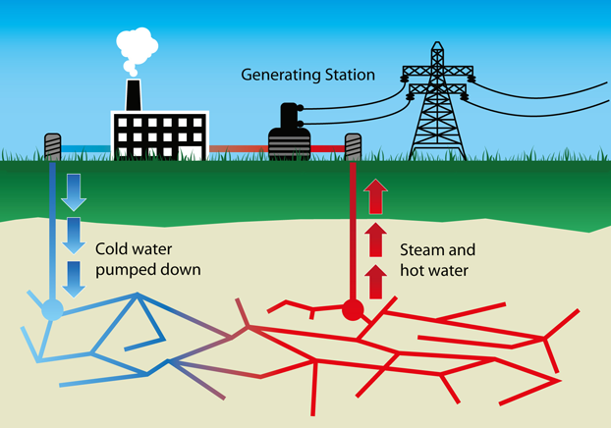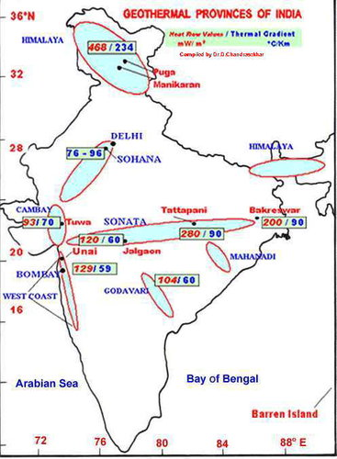
India with a coastline of more than 6000Km, OCEAN ENERGY can be harnessed 24hrs a day all the year round. This energy can be tapped right on the shores. A 15 Km stretch of ocean front could have energy equivalent to 1000MW.Ocean energy is continuous and predictable.
Tidal power is inexhaustible, is independent of Rains, even a continuous dry spell of any number of years can have no effect on tidal power generation. It is also pollutant free. Power plants do not demand large areas of valuable lands as they are on the bays. The possible sites in India are Gulf of Kutch, Gulf of Cambay and Sundarbans.
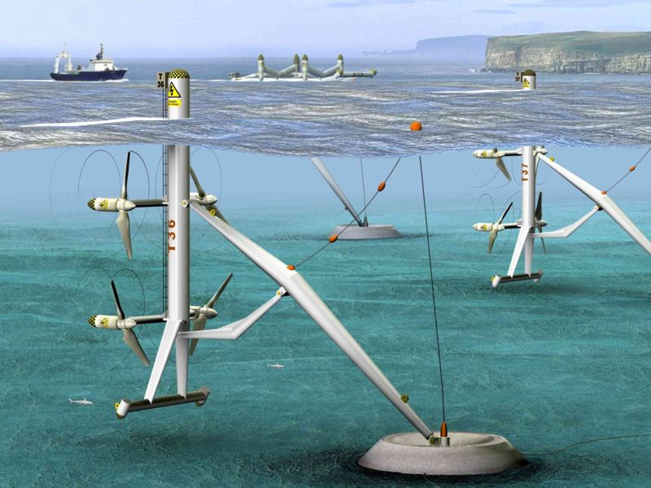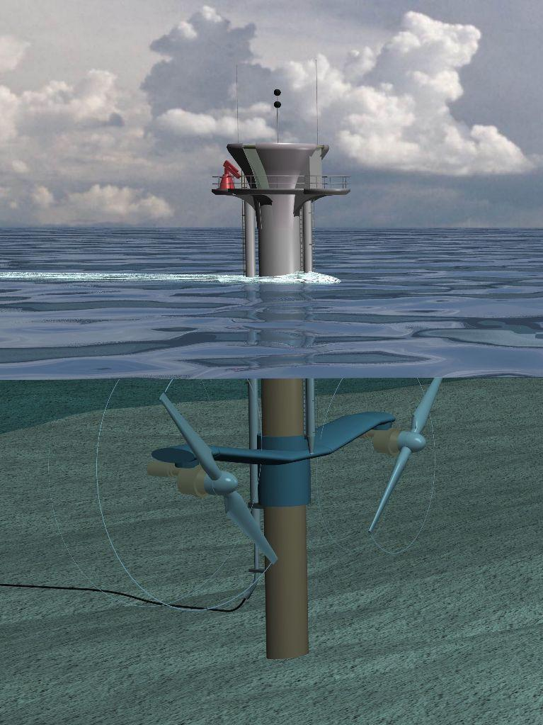
Finally, the reserves of fossil fuels i.e. oil, natural gas, coal and nuclear energy (fission process) which supplies most of the energy consumption is limited. The need of the hour is to explore and develop NON-CONVENTIONAL and RENEWABLE ENERGY to meet the growing demand of energy. Since energy needs, of developing countries like India, which has a future of becoming a super power is going to increase significantly. It is absolutely necessary to plan for the critical input, so that the Country’s development is not hampered.

  

