Crossing Over
Crossing over is the interchange of chromosomal parts between non-sister chromatids of a homologous pair of chromosomes resulting in recombination of genes
Crossing over was discovered by Morgan
Crossing over is the interchange of chromosomal segments between the homologous chromosomes
It occurs during meiosis or gametogenesis
The crossing over occur only between non-sister chromatids of the homologous chromosomes
The number of crossing over depends upon the length of the chromosome. The longer the length, the higher the percentage of crossing over
When the genes are located distantly the change for crossing over is higher. When the genes are closely located the change for crossing over is lesser
The number of crossing over between two genes is represented by percentage of crossing over
The percentage of crossing over is directly proportional to the distance between two genes
The percentage of crossing over is the expression of the number of recombinaations in percentage to the total number of offspring
Percentage of total number of
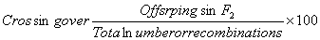
The percentage of crossing over is also called frequency of crossing over
Thus percentage of crossing over = Frequency of crossing over =Percentage of recombination
Generally crossing over is less frequent neat the centromere and the tip of the4 chromosome
Crossing over at one point prevents another crossing over nearby
When there is a single crossing over in a homologous chromosome, it is called single crossing over
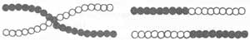
When there are two cross over in a homologous chromosome, it is called double crossing over
When there are many cross over in a homologous chromosome, it is called multiple crossing over
The crossing over may be formed between two strands or 3 stands or 4 strands. It is always formed between non-sister chromatids
Crossing Over in Drosophila
The phenomenon of crossing over is well illustrated in Drosophila melanogaster. When grey long Drosophila is crossed with a black vestigial, the F1 hybrid is grey long
When female flies of F1 generation are back crossed with double recessive male, four types of offspring are produced Among the four types of offspring, two types are black vestigial and grey long are just like the parents and they are known as parental combinations.
Among the F1, about 41.5% of flies are like the dominant parent and another 41.5% are like the recessive parent
The other two types grey vestigial and black long are different from their parents genotypically and phenotypically and they are known as non-parental combinations. The non-pa-rental combinations of F1 flies include 8.5% grey vestigial and 8.5% black long
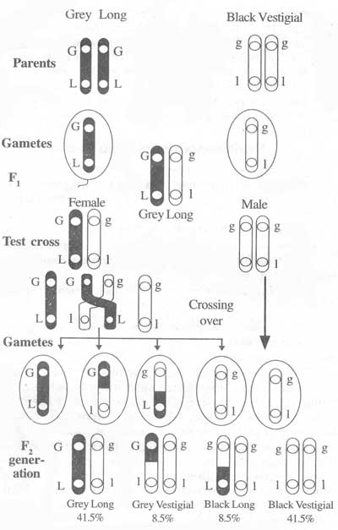
Crossing Over in Drosophila
The F1 female hybrid produces four towards each other and come to lie side by side.
This phenomenon of pairing of homologous chromosomes is 4 kinds eggs. Two types of eggs carry the linked genes in original combination. But the other two types of eggs carry the linked genes in original combination. But the other two types of eggs carry the genes in a new combination. If the law of independent assortment of genes takes place in the above cross, all the F2 offspring are in equal numbers
(1:1:1:1) as a result of back cross.
The actual results of the above cross indicates that the law of independent assortment is not operating in these crosses.
Significance of Crossing Over
Crossing over is of great significance.
1. Linear arrangement of genes: Crossing over clearly illustrates the linear arrangement of genes in the chromosomes.
2. Chromososme Maps: The frequency of crossing over is very useful to construct the chromosome maps.
3. Recombination: Crossing over produces new combination of genes.
4. Variations: Crossing over leads to genetic variation which is the raw material for evolution.
Mechanism of Crossing Over
Crossing over is the interchange of chromosomal segments between non-sister chromatids.
Crossing over occurs during meiosis of gametogenesis. The homologous chromosomes move toward each other and come to lie side by side. This phenomenon of pairing of homologous chromosomes is called synapsis. The paired homologous chromosomes are called bivalents.
The homologous chromosomes split longitudinally. Each chromosomes splits into two chromatids. Hence four chromosomes. This stage is called tetrad stage. The two chromatids of a chromosome are attached by a single centromere. These are called sister chromatids.
The non-sister chromatids of homologous chromosomes twist over other. At certain points, the non-sister chromatids are connected with each other. The points of contact between non-sister chromatids are called chiasmata (chiasma=singular). Chiasma means a cross.
At the chiasma the chromatids break. This is brought about by an enzyme called endonuclease. The broken segment of one chromatid is fused with the other chromatid and vice versa. This fusion is brought about by another enzyme called ligase. The process of fusion is called ligation. The exchanges of chromosomal segments between non-sister chromatids is called crossing over.
After crossing over the non-sister chromatids repel each other. They separate from each other from twisting. The separation is called terminilization. This leads to the separation of homologous chromosomes.
Chiasma Type Theory
This theory was proposed by Janssen. This theory suggests that prior to crossing over, the chromosomes of each bivalent get duplicated to form a tetrad. Crossing over occurs only between the non-sister chromatids overlap with one another and form chiasma or point of contact. In the chiasma,
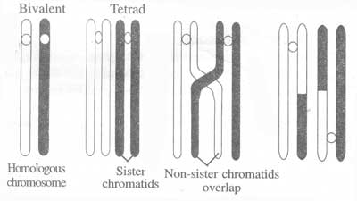
Diagram showing chiasma formation and crossing over
the chromatids break and they rejoin with the mutual exchange of segments. The other two chromatids remain intact. This theory is known as chiasma type theory.
The Breakage First theory
This theory was proposed by Muller. According to this theory, the non-sister chromatids of homologous chromosomes first break off without crossing over. The broken segments rejoin to form new combinations.
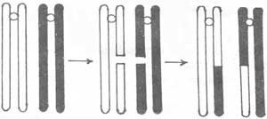
Contact First theory
This theory was proposed by Serebrovsky. According to this theory the non-sister chromatids first touch and cross each other. The breakage occurs at the points of contact of the chromatids. The broken segments rejoin to form new combinations.
Strain or Torsion Theory
This theory was proposed by Darlington. According to this theory, the homologous chromosomes (bivalent) are relationally coiled around each other in a specific fashion.
The chromosomes duplicate and the two sister chromatids in each chromosome are also coiled one around the other. When the chromosomes start separating their relational coiling, unravel in one direction and the sister chromatids unravel in the opposite direction. The repulsion causes torsion, which exerts pressure or strain on the weak non-sister chromatids. The non-sister chromatids break at the point of contact and broken ends rejoin and form chiasma.
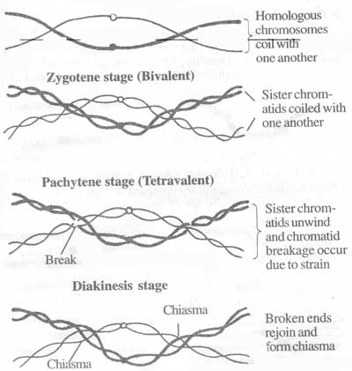
Strain or theory of crossing over
Differential Contraction Theory
Huskin suggested that tension set up by differential contraction after pairing may cause breaks at overlap. Separation starts from the centromere towards the ends like a zip. This separation is called terminalization. This leads to the separation of homologous chromosomes.
Based upon the number of chiasmata formed, crossing over may be classified into three types. They are as follows:
1. Single Crossing Over
In this type, only one chiasma is formed. Only one chromatid of each chromosome is involved in single crossing over
Double Crossing Over
In this type, two chiasmata are formed. The chiasmata may be formed between the same chromatids or between different chromatids. Thus two or three or all the four chromatids of the homologous chromosomes may be involved in the process of double crossing over.
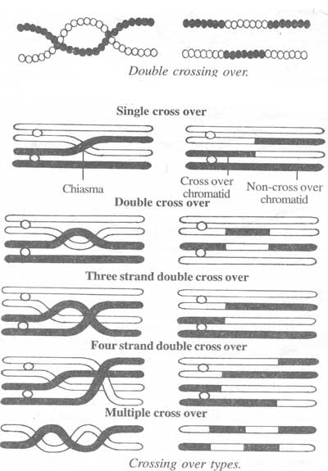

a. Two strand double crossing over:
In this type, the two non-sister chromatids are involved at both the crossing over points. Here two chromatids are non-cross overs and maintain the parental combination of genes.
b. Three strand double crossing overs:
In this type, three chromatids are involved in the formation of chiasmata. Here three chromatids exchange their parts and one chromatid is non-cross over.
c. Four strand double crossing overs:
In this type, all the four chromatids are involved in the formation of chiasmata.
3. Multiple Crossing Over
In this type, more than two chiasmata are formed. Multiple crossing over is very rare because of interference in crossing over.
Factors Affecting Crossing Over
1. High temperature increases the frequency of crossing over.
2. X-ray increases the frequency of crossing over.
3. The frequency of crossing over decreases with increasing age in female Drosophila.
4. Some genic mutation decreases the frequency of crossing over.
5. Crossing over is less frequent near centromeres and the tips of the chromosomes.
6. Inversions of chromosome segments suppress the crossing over.
7. Chiasma formation at one point prevents the chiasma formation in the vicinity. This phenomenon is known as interference.
Evidence for Crossing Over
Crossing over is the interchange of chromosomal parts between homologous chromosomes. This is cytologically proved by Stern in Drosophila.
The female Drosophila carries XX chromosome and the male Drosophila carries one X chromosome and one Y chromosome.
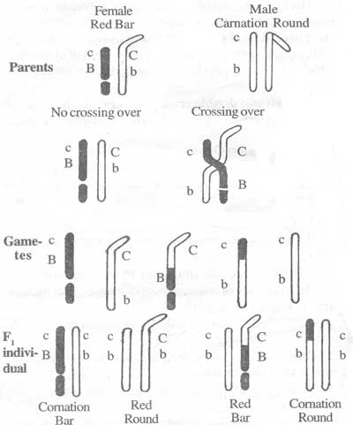
Cytological proof for crossing over
In a type of female Drosophila, the two X chromosomes are different from each other. An X chromosome has a piece of Y chromosome attached to it. The other X chromosome has been broken into two unequal segments and it is shorter than the unbroken X chromosome. Thus the two X chromosomes are structurally different from the normal X chromosomes. Both the chromosomes can be distinguished by microscopic examination.
In Drosophila, red eye (C) is dominant and carnation eye is recessive (c). Similarly bar eye is dominant (B) and round eye (b) is recessive.
The broken X chromosome contains a recessive gene (c) for carnation eye colour and a dominant gene (B) for bar eyes, while its homologue contains C and b.
This female having red bar eyes is crossed with a double recessive male having carnation round eyes.
In the absence of crossing over, only two types of female gametes are produced; one type having broken X containing c and B genes; the other type having the X with a piece of Y attached containing C and b.
But if crossing over occurs two more types of gametes are produced; one type having c and b in a normal size X and the other type having C and B on a broken X with a piece of Y chromosome. These four types of gametes, after fertilization will produce four types of offspring and they are
1. Carnation bar
2. Red round
3. Carnation round and
4. Red bar.
The X chromosome of these four types are then identified. Each offspring has the expected chromosomal configuration.
This experiment proves that interchange of chromosomal material takes place between the homologous chromosomes.
Linkage
Linkage is defined as the tendency of two or more genes to remain together in the original combination in the same chromosome during the process of inheritance for a number of generations. All the genes on a chromosome are said to be linked to one another.
Linkage was discovered by T.H. Morgan.
Linkage was found in Drosophila, sweet peas, maize, man, etc.
In Drosophila, the genes of body colour and nature of wings are linked and located on the same chromosome.
In sweet pea, the genes of flower colour and size of pollen grains are linked.
In maize, the genes for colour and shape of seeds are linked.
In man, the genes for haemophilia and colour blindness are linked.
T.H. Morgan (1911) proposed the theory of linkage based on his experiments in Drosophila. The theory of linkage explains the main principles of linkage. They are the following:
1. A chromosome contains many genes.
2. The genes are arranged in a linear fashion on the chromosome
3. The genes present in a chromosome are chromosome linked.
4. The linked genes are inherited together from the parents to the offspring.
5. Linkage is a rare phenomenon when compard to crossing over.
6. The strength of linkage depends on the distance between the linked genes. Closely located genes show strong linkage. Widely located genes show weak linkage.
Linkage in Drosophila
In Drosophila, grey colour (G) is dominant over black colour(g) and long wing (L) is dominant over vestigial wing (l).
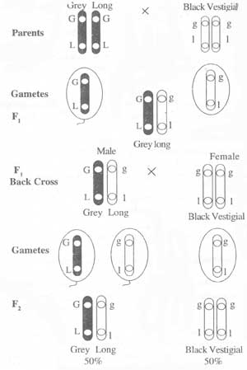
Linkage in Drosophila
The genes for these two characters (colour of the body and length of the wings) are linked together in the same chromosome.
When a fly with grey body and long wings (GGLL) is crossed with another fly having black body and vestigial wings (ggll), all the F1 individuals are having grey body and long winds (GgLl).
When F1 male hybrid is test crossed with the double recessive parent, the F2 contains only two types of individuals in equal numbers (1:1 ratio) instead of the expected 1:1:1:1 dihybrid test cross ratio.
The resulting offspring are resembling the grand parents. This is because gene G is linked with L and the gene g is linked with l.
Linkage Groups
All the linked genes of a homologous pair of chromosome form one group called linkage group.
In Drosophila, there are four linkage groups corresponding to the four pairs of chromosome. 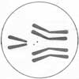
The garde pea plant has seven pairs of chromosome and has 7 linkage groups.
Man has 23 linkage groups corresponding to 23 pairs of chromosome.
Each linkage group has a particular number of genes. The number of genes is proportional to the length of the chromosome.
In Drosophila, the smallest chromosome has the smallest linkage group of 12 linked genes. The largest chromosome has the largest linkage group of 150 linked genes.
Factors Affecting Linkage
Linkage is affected by the following factors:
1. Distance: Closely located genes show strong linkage while genes widely located show weak linkage.
2. Age: With increasing age the strength of linkage decreases.
3. Temperature: Increasing temperature decreases the strength of linkage.
4. X-rays: X-ray treatment reduces the strength of linkage.

